**[Example]**

Two useful abbreviations that can be used in specifying file paths are one dot (.) and two dots (..). One dot means “current folder” and two dots means “parent folder of the current folder”.

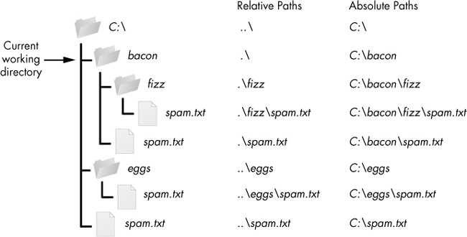

**[Practice]**

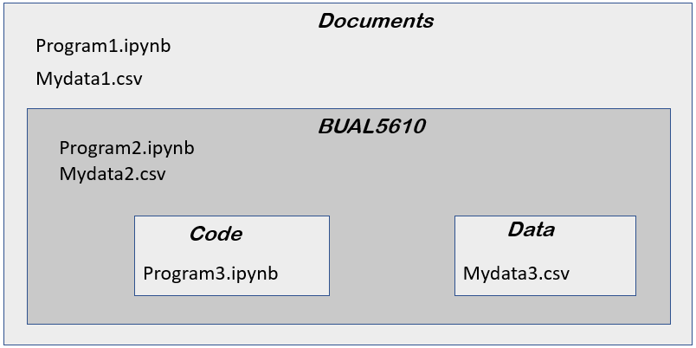

For Program1.ipynb:

* To read Mydata1.csv:__ 'Mydata1.csv'______________________________________
* To read Mydata2.csv:_'./BUAL5610/Mydata2.csv'_or 'BUAL5610/Mydata2.csv' ____
* To read Mydata3.csv:____________________________________________________

For Program2.ipynb:

* To read Mydata1.csv:__ '../Mydata1.csv'_____________________________________
* To read Mydata2.csv:____________________________________________________
* To read Mydata3.csv:____________________________________________________

For Program3.ipynb:

* To read Mydata1.csv:____________________________________________________
* To read Mydata2.csv:____________________________________________________
* To read Mydata3.csv:____________________________________________________